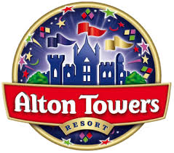

Alton Towers Resort launches 2020 Season Pass deals for Black Friday
Alton Towers Resort has slashed the prices of its Standard and Premium Season Passes in time for Black Friday, giving families and thrill seekers up to £10 off their 2020 passes!

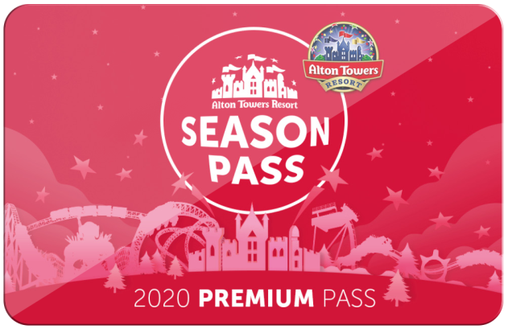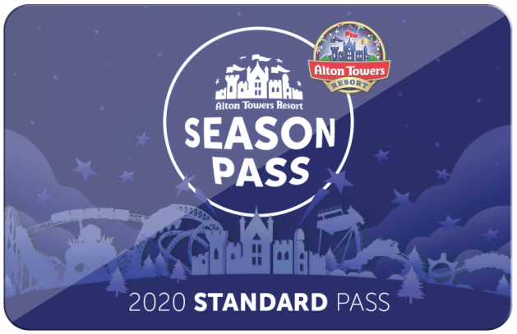
From midnight on Friday November 29th you will be able to bag yourself access to the UK’s number one Theme Park for just £50 (normally £58) with a Standard Season Pass or £65 (normally £75) for a Premium Season Pass.
Passholders will unlock season-long access to the Theme Park’s rides and attractions including the £16 million ride Wicker Man, world renowned coasters Nemesis, Oblivion and The Smiler, as well as family rides and attractions such as Runaway Mine Train, HEX and Sharkbait Reef by SEALIFE. Families can also enjoy the UK’s only CBeebies Land, with 16 CBeebies-themed rides and attractions. With the chance to meet some of CBeebies’ most popular characters, it’s the perfect place for young children to learn, play and inspire their imaginations.

New for 2020, the Premium Season Pass includes FREE standard car parking (usually priced at £6 per visit), along with entry to the Alton Towers Dungeon and unlimited access on peak days during Summer and Scarefest.
All 2020 Passholders will receive exclusive discounts and perks, as well as being first to receive news from the Resort. The hotly anticipated new family attraction inspired by the books of David Walliams is due to open in Spring 2020, and Alton Towers will also be celebrating 40 years as the nation’s favourite destination for rollercoaster fans with a range of activities through-out the year. So there are plenty of great reasons to visit the Alton Towers Resort in 2020.
The Black Friday offer will be available online only from midnight Friday 29th November until 23:59 on Cyber Monday 2nd December at www.altontowers.com. Terms and conditions apply.
ENDS
Season Pass Information
Alton Towers 2020 Season Pass | Standard | Premium
Normal Price | £58 | £75
Black Friday Price | £50 | £65
Exclusion Dates | Weekends in August, Scarefest | None
Car Parking | £6 | Included
Alton Towers Dungeon | From £5 in advance | Included
Other benefits | A range of other perks will be on offer through the year, which could include discounts in the resort’s shops, restaurants or digital photo passes

Images can be downloaded here.
For more information, please contact the Alton Towers Resort press office on 01538 704011 or email sarah.thomas@alton-towers.com.

About Alton Towers Resort

For generations, Alton Towers Resort has offered families the chance of a great escape with rides, attractions and entertainment for thrill-seekers, families and kids of all ages!

The Resort is home to seven world-class rollercoasters including the latest addition Wicker Man that brings together wood and fire, the iconic twists and turns on Nemesis, Oblivion’s vertical drop and The Smiler’s world-record 14 inversions. 2019 also saw the launch fo the Alton Towers Dungeon, offering laughs and screams as you journey through Staffordshire’s darkest history.

For those with little ones in tow, head over to CBeebies Land to meet some of your favourite characters including the Teletubbies, Peter Rabbit and Postman Pat. Families can also discover Sharkbait Reef by SEA LIFE, learn to drive at Cuckoo Cars Driving School, catch the Runaway Mine Train or enjoy the spins and thrills on Spinball Whizzer!

The Resort boasts four themed hotels and glamping-style Stargazing Pods, indoor waterpark, high ropes course, luxury spa and eighteen-hole crazy-golf course.

And new for 2020, The World of David Walliams will be joining the line-up at Alton Towers as the Resort celebrates 40 years as the UK’s leading theme park.

